MED D - Test Claim - Addressing Medications Available in Multiple Forms

Addressing Medications Available in Multiple Forms
Related Documents

Description: This document provides general reminder for addressing medications available in multiple forms.

Addressing Medications Available in Multiple Forms
Some medications come in different forms such as tablets, granules, liquids, etc…

It is important to ask the caller to specify which version of medication they are taking. The name can be located on the prescription bottle.

Example: Metoprolol is one medication that comes in multiple forms. (Metoprolol SUC, Metoprolol Tar, and Metoprolol ER)

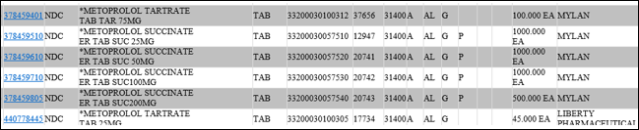

If the caller questions the difference in the medication, please reach out to Clinical Care Services for assistance.

Note: If the claim rejects, review the rejection code to determine what caused the rejection. Once the rejection code is identified, access the proper work instruction and job aids in theSource to help you resolve the issue.

Top of the Document

Related Documents
MED D - Test Claim Index
Quantity Versus Time Limit (QVT)

Parent SOP: CALL-0049: Customer Care Internal and External Call Handling
Abbreviations / Definitions: Customer Care Abbreviations, Definitions, and Terms

Top of the Document

Not To Be Reproduced Or Disclosed to Others Without Prior Written Approval
ELECTRONIC DATA = OFFICIAL VERSION – PAPER COPY – INFORMATIONAL ONLY

